1) 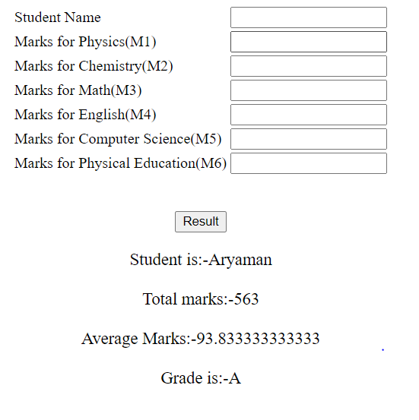<html>

<body>

<form action="" method="post">

<center>

<table border=0>

<tr>

<td>

Student Name

</td>

<td>

<input type=text name="t1">

</td>

</tr>

<tr>

<td>

Marks for Physics(M1)

</td>

<td>

<input type=text name="t2">

</td>

</tr>

<tr>

<td>

Marks for Chemistry(M2)

</td>

<td>

<input type=text name="t3">

</td>

</tr>

<tr>

<td>

Marks for Math(M3)

</td>

<td>

<input type=text name="t4">

</td>

</tr>

<tr>

<td>

Marks for English(M4)

</td>

<td>

<input type=text name="t5">

</td>

</tr>

<tr>

<td>

Marks for Computer Science(M5)

</td>

<td>

<input type=text name="t6">

</td>

</tr>

<tr>

<td>

Marks for Physical Education(M6)

</td>

<td>

<input type=text name="t7">

</td>

</tr>

</table>

<br>

<br>

<input type=submit name="s" value="Result">

</center>

<?php

if(isset($_POST['s']))////checking whether the input element is set or not

{

$a=$_POST['t1']; //accessing value from 1st text box

$a1=$_POST['t2']; //accessing value from 2nd text field

$a2=$_POST['t3']; //accessing value from 3rd text field

$a3=$_POST['t4']; //accessing value from 4th text field

$a4=$_POST['t5']; //accessing value from 5th text field

$a5=$_POST['t6']; //accessing value from 6th text field

$a6=$_POST['t7']; //accessing value from 7th text field

$sum=$a1+$a2+$a3+$a4+$a5+$a6; //total marks

$avg=$sum/6;

if($avg<50)

$grade="Fail";

if($avg>=50&&$avg<60)

$grade="E";

if($avg>=60&&$avg<70)

$grade="D";

if($avg>=70&&$avg<80)

$grade="C";

if($avg>=80&&$avg<90)

$grade="B";

if($avg>=90&&$avg<95)

$grade="A";

if($avg>95)

$grade="S";

echo "<br>";

echo "<font size=4><center>Student is:-".$a."</center><br>";

echo "<font size=4><center>Total marks:-".$sum."</center><br>";

echo "<font size=4><center>Average marks:-".$avg."</center><br>";

echo "<font size=4><center>Grade is:-".$grade."</center>";

}

?>

</form>

</body>

</html>

2) 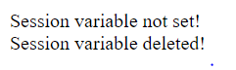<html>

<body>

<?php

session_start();

if(isset( $_SESSION['Favcolor'] ))

echo "Session variable is set!<br>";

else

echo "Session variable not set!<br>";

unset($_SESSION['Favcolor']);

if(isset( $_SESSION['Favcolor'] ))

echo "Session variable is alive!<br>";

else

echo "Session variable deleted!<br>";

session_destroy();

?>

</body>

</html>

3) 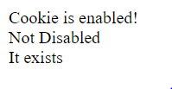<html>

<body>

<?php

$cookie_name="course";

setcookie($cookie_name, "IWP", time()+(3600)*72);

if(!isset($_COOKIE[$cookie_name])) {

echo "Cookie named is not enabled!";

} else {

echo "Cookie is enabled!<br>";

}

echo (isset($_COOKIE["course"]) && $_COOKIE["course"]=="IWP") ? 'Not Disabled' : 'Disabled';

echo "<br>";

if($_COOKIE["course"])

echo "It exists";

else

echo "It does not exists.";

if (isset($_COOKIE["course"])) {

unset($_COOKIE["course"]);

setcookie("course", "", time()-3600);

return true;

} else {

return false;

}

?>

</body>

</html>